**OCN NI Level 2 Certificate in Essential Skills**

**Application of Number**

**The Café**

|  |  |
| --- | --- |
|  | |
|  | |
|  | |
|  | |
|  | |
|  | |
| OCN NI Use Only | |
| Q | Mark |
| 1a(i) |  |
| 1a(ii) |  |
| 1b |  |
| 1c |  |
| 1d |  |
| 1e |  |
| 2a |  |
| 2b |  |
| 2c |  |
| 2d |  |
| 2e |  |
| 2f |  |
| 2g |  |
| 2h(i) |  |
| 2h(ii) |  |
| **Total** |  |

**Learner name (Block Capitals) ________________________**

**Learner signature___________________________________**

**Centre____________________________________________**

**Assessment Date___________________________________**

**Instructions to candidates:**

**You should have the following for this assessment:**

* Pen with black or blue ink
* Pencil and eraser
* 30 cm ruler
* Calculator
* Protractor

**General Instructions:**

* There are 2 tasks to complete
* You must attempt both tasks
* Each task is worth 25 marks
* Read through each task carefully
* Show your working out; you may get marks for it
* Write all your working out and answers in this booklet
* Check your calculations
* Remember to put units on your answers
* Total marks available:  **50**
* You have **1½ hours** to complete the assessment.

Pass Mark %

Candidate Mark %

**Task 1 - The Café**

Ella’s Café employs 8 members of staff at present.

Their job roles and rates of pay per hour are listed in the table below:

|  |  |  |
| --- | --- | --- |
| **Job role** | **Staff member** | **Basic rate of**  **pay per hour** |
| Kitchen porter | Beth | £6.70 |
| Patrick | £6.12 |
| Floor and Counter staff | Lesley | £6.80 |
| Raj | £6.68 |
| Barista | Louise | £7.20 |
| Tanya | £7.20 |
| Food preparation staff | Marek | £6.86 |
| Jane | £7.24 |

**1a(i)** What is the average (mean) rate of pay in Ella’s café?

(**2 marks)**

Show your working clearly below:

Average (mean) rate of pay: £___________

Ella decides that she will also need a supervisor to help her run the café.

She will pay the supervisor a basic rate of pay of £8.92 per hour.

**1a(ii)** How will this affect the average (mean) rate of pay in Ella’s café?

**(3 marks)**

You **must** use calculations to justify your answer.

Show your working clearly below:

Effect on average rate of pay in Ella’s café: ____________________________

______________________________________________________________

Leon is employed as the Café Supervisor at Ella’s Café.

He took a loan to pay his fees when he was at college.

Each week 9% of any earnings **over** £366 will be taken from his wages to pay back his loan.

In his first week of work Leon worked the following hours:

36 hours @ £8.92 per hour

9 hours @ £10.32 per hour (overtime rate)

**1b** How much of his loan will Leon pay back in his first week of work? **(4 marks)**

Show your working clearly below:

Amount of loan to be paid back in first week of work: £___________

**Page intentionally left blank**

The scale drawing below shows a plan of the storeroom in Ella’s café.

Ella intends to paint the floor area with hardwearing floor paint.

**Plan of Storeroom**

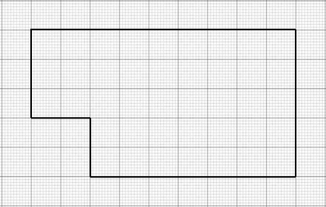

**Scale 1:50**

Ella has a tin of floor paint that will cover up to 18 m².

**1c** Ella thinks this will be enough paint to give the floor 2 coats of paint.

Is she correct? **(7 marks)**

Use calculations to justify your answer on the opposite page.

**1c**

Will Ella have enough paint? : _____________

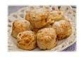Jane bakes scones each morning at Ella’s Café.

She uses baking trays measuring 40cm by 35cm.

She cuts circular scones from the unbaked dough using a cutter of diameter 8cm.

The diameter of the scones can increase by up to 20% during baking.

No further allowance needs to be made when spacing the scones out on the tray.

**1d** How many scones can Jane fit on one baking tray? **(5 marks)**

Show your working clearly below using sketches if necessary.

Number of scones Jane can fit on one tray:________

Last week 1600 hot drinks were sold in Ella’s Café.

The ratio of cups of coffee to cups of tea sold is 7:3.

A cup of coffee on average costs £2.30.

A cup of tea on average costs £1.80.

**1e** How much can Ella expect to have made through sales of cups of coffee and tea last week?

**(4 marks)**

Show your working clearly below.

Amount Ella can expect to have made: £____________

**Task 2 - The Café Suppliers**

Delia has set up a business making cakes and selling them to local cafés.

She decorates her cakes with different coloured sweets.

The sweets are all the same shape and size but they vary in colour.

The tally chart below shows the number of each colour of sweet in a bag:

|  |  |
| --- | --- |
| **Colour of sweet** | **Tally** |
| Red | ~~||||~~ ~~||||~~ ~~||||~~ ~~||||~~ ~~||||~~ |
| Yellow | ~~||||~~ ~~||||~~ ~~||||~~ | |
| Green | ~~||||~~ ~~||||~~ ~~||||~~ ~~||||~~ |||| |
| Blue | ~~||||~~ ~~||||~~ |

Delia picks a sweet randomly from the bag.

**2a** What is the probability that the sweet will be green? **(3 marks)**

Express you answer as a percentage.

Show your working clearly on the opposite page.

**2a**

Probability of choosing a green sweet: ________%

Delia is making a batch of cakes in cylindrical tins.

The tins have a **diameter** of 20cm and a **height** of 9cm

r

h

.

Tins are filled to 4cm below the top to allow room for the cake mixture to rise.

**2b** Delia has made 2 litres of cake mix.

Will this be enough for one tin? **(6 marks)**

Use the following formula:

**V = π $r^{2}$ h**

where r is the radius of the circular cake tin base and h is the height of the cake tin.

Let **π = 3.14** or use the π button on your calculator.

Note that **1cm3 = 1ml**

You **must** show calculations to justify your answer in the space on the opposite page.

**2b**

**Is there enough cake mixture to fill one tin? : ___________**

The road network below (not to scale) shows the locations of cafés that Delia delivers to on Monday.

It also shows the location of the wholesaler and Delia’s home.

The distances between locations are marked in miles.

**You will need to use this road network in questions 2c and 2d.**

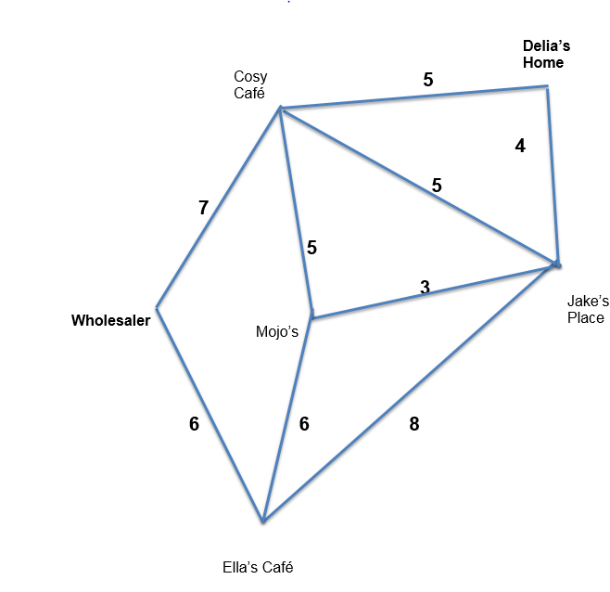

**2c** Calculate the length of the shortest route that Delia can take in order to deliver cakes to all her customers.

She must start at home and finish at the wholesaler. **(2 marks)**

Show working clearly below with your chosen route clearly described:

**Distance: _____________ miles**

On Saturday Delia leaves home and visits Cosy Café, Mojo’s and Jake’s Place.

She then returns home.

Delia allows 20 minutes to load her deliveries into her van at home.

She needs to return home by 10.20am.

She allows 15 minutes for parking and delivery at each of the cafés she stops at.

Delia drives at an average speed of 34 miles per hour.

**2d** Delia sleeps in and leaves the house at 9am.

Will she be able to complete her deliveries and return home on time?

**(6 marks)**

Use the formula:

$$t=\frac{d}{s}$$

where t = time, d = distance and s = average speed.

You **must** show calculations to justify your answer in the space on the opposite page.

**2d**

Will Delia be able to complete her deliveries and return home on time?

__________________________________________________________

**2e** Show one way of checking your calculation in question 2d: **(1 mark)**

Tony, the local butcher, supplies meat to local cafes and restaurants in his refrigerated van.

Several hours after loading the van Tony realizes that the van freezer unit has not been working.

The temperature in the unit has risen by 3.4°C from the original temperature of -19.6°C.

Food safety guidelines say that:

**Frozen food must be kept at a temperature of -18**°**C** **or below.**

**2f** Using the frozen food safety guide shown, advise Tony whether he can supply frozen meat safely to customers. **(2 marks)**

You must justify your answer.

Show your working and answer below:

Will Tony be able to supply frozen meat safely? ____________________

Tony the butcher must buy a new refrigerated van.

The van he owns at present is 8 years old.

Tony wants to know what his current van is worth.

The scatter graph below shows the value and age of a number of vans similar in type to the van Tony owns.

A line of best fit has been drawn.

**2g** Use the graph to estimate the value of Tony’s 8 year old van to

the nearest £1000. **(1 mark)**

Draw lines on the graph to justify your answer.

Estimated value: £_____________

Tony sees the advertisement below in the local newspaper.

# Fjord Transit Refrigerated Van £18,300

# 

The company selling the van offers the following finance agreement:

Minimum deposit £7500

with the balance payable over 12 months at 5% interest!

Tony can raise enough money to pay the minimum deposit on this new van.

**2h(i)** What will be the total interest charged on the balance? (**2 marks)**

Show your working in the space below:

Amount of interest charged: £________

Tony can afford to pay up to £1000 per month.

**2h(ii)** Can Tony afford to buy this van? **(2 marks)**

You **must** show calculations to justify your answer in the space below:

Can Tony afford to buy the van? ____________